James Riordan

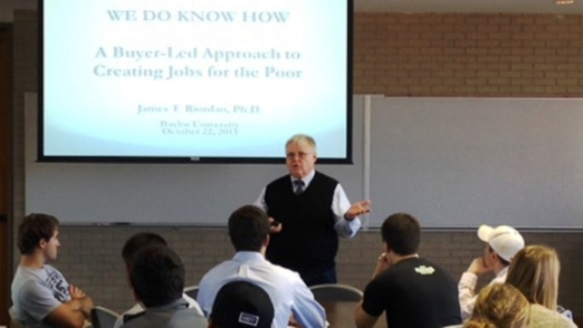
Contact Information
Email: | James_Riordan@baylor.edu

Biography

Dr. James T. Riordan is a development economist with more than 40 years of experience in the design and implementation of business development, anti-poverty, food security, rural development, and policy reform programs around the world. Jim has lived in Colombia, Peru, Egypt, and Albania and worked in 62 countries. Early in his career, Jim worked for the U.S. Department of Agriculture, USAID, Abt Associates Inc., Iowa State University, and The Ohio State University. For most of the last 25 years, he was a director at Chemonics International Inc. From 1999 until 2003, Jim directed USAID/Peru’s Poverty Reduction and Alleviation (PRA) program, managing business promotion centers in 11 economic corridors in the country’s interior. By its end in 2008, PRA had generated more than $307 million in new sales and created 81,900 new jobs. For its innovative buyer-led approach to attacking poverty, the program received Peru’s prestigious Creatividad Empresarial award. Since 2003, Jim has helped apply key elements of the approach in more than a dozen other countries. In 2011, he completed We Do Know How: A Buyer-Led Approach to Creating Jobs for the Poor, published by New Academia Publishing. It presents the rationale for the approach and how to apply it. He has a PhD in economics and an MA in international relations from the University of Pennsylvania, and an MA and a BA in mathematics from Fordham University.

We Do Know How: A Buyer-Led Approach to Creating Jobs for the Poor
Haut du formulaire
Bas du formulaire

